1 The HC-SR04 ultrasonic sensor uses sonar to determine the distance to an object in the same way that bats an dolphins do. It has a range of 2cm to 400cm and has a transmitter and receiver module. It works best within a spread of 30 degrees.

To start measurement, Trig of SR04 must receive a pulse of high (5V) for at least 10us, this will initiate the sensor which will transmit out 8 cycle of ultrasonic burst at 40kHz and wait for the reflected ultrasonic burst. This will be reflected by anything in front of the sensor and the reflected waves will be detected by the ultrasonic receiver. The SR04 will set the Echo pin to high (5V) and keep this high for a period of time which will be in proportion to distance. To obtain the distance, measure the time the Echo pin is high (otherwise called Width of Echo Pulse)

This time can then be converted to a distance measurement.

Time = Width of Echo pulse, in uS (micro second)

Distance in centimeters = Time / 58

Distance in inches = Time / 148

Or you can utilize the speed of sound, which is 340m/s

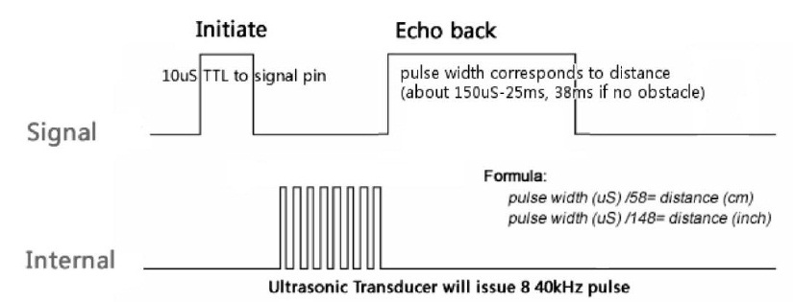

The HC-SR04 has four connections

* +5v Supply
* Trigger Pulse Input
* Echo Pulse Output
* 0V - Ground

2 Components required

* Arduino Board (e.g Nano v3.0)
* Ultrasonic Detector (e.g. HC-SR04)
* BreadBoard
* Connecting Wires

3 Wire up your components using the following diagram

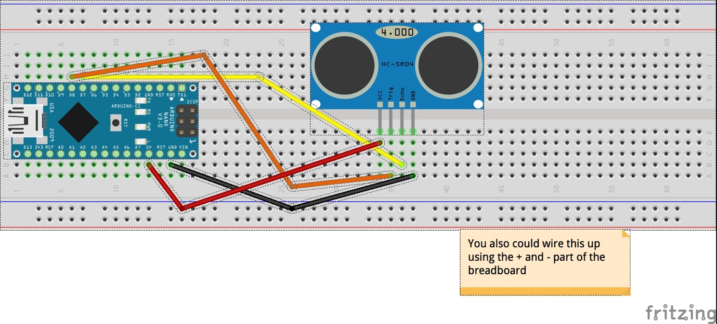

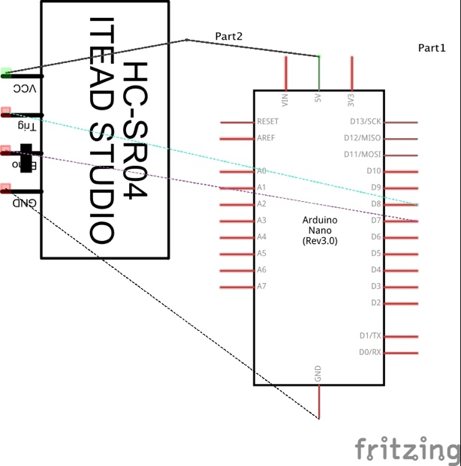

4 Open the Arduino sketch – HC-SR04_Sketch.ino or similar

#define echoPin 7 // Echo Pin

#define trigPin 8 // Trigger Pin

#define LEDPin 13 // Onboard LED

int maximumRange = 200; // Maximum range needed

int minimumRange = 0; // Minimum range needed

long duration, distance; // Duration used to calculate distance

void setup() {

Serial.begin (9600);

pinMode(trigPin, OUTPUT);

pinMode(echoPin, INPUT);

pinMode(LEDPin, OUTPUT); // Use LED indicator (if required)

}

void loop() {

/* The following trigPin/echoPin cycle is used to determine the

distance of the nearest object by bouncing soundwaves off of it. */

digitalWrite(trigPin, LOW);

delayMicroseconds(2);

digitalWrite(trigPin, HIGH);

delayMicroseconds(10);

digitalWrite(trigPin, LOW);

duration = pulseIn(echoPin, HIGH);

//Calculate the distance (in cm) based on the speed of sound.

distance = duration/58.2;

if (distance >= maximumRange || distance <= minimumRange){

/* Send a negative number to computer and Turn LED ON

to indicate "out of range" */

Serial.println("-1");

digitalWrite(LEDPin, HIGH);

}

else {

/* Send the distance to the computer using Serial protocol, and

turn LED OFF to indicate successful reading. */

Serial.println(distance);

digitalWrite(LEDPin, LOW);

}

//Delay 50ms before next reading.

delay(50);

}

5 This example uses pin 7 for echo and pin 8 for Trigger. It use the Arduino standard pulseIn function to obtain the duration (result of the Echo) and then convert that value to a distance. Then it prints that value out to the Serial port which can be displayed in the Serial monitor tool of the Arduino IDE (remember to match the board rate!) It also sets LEDPin 13 to low to indicate a reading was successful.

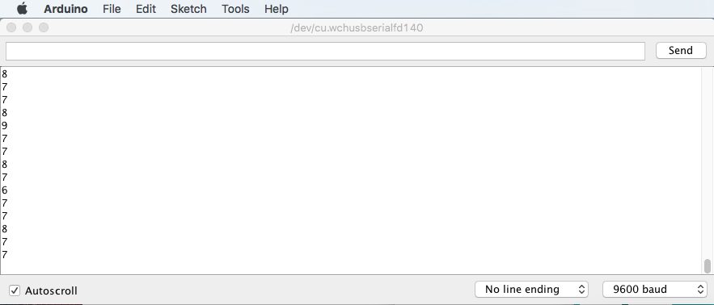

Give it a try!

6 What projects can you make using Ultrasonic sensors?